**Finishing Tool Suite v9.8.7**



by Nat Cagle

An ArcGIS toolbox containing a suite of script tools   
designed to automate many of the data preparation and   
repair steps necessary for the Finishing process.

# Contents

About The Project

Prerequisites

Tool Features

Roadmap

Usage

Acknowledgments

# About The Project

**DO NOT TRY TO RUN THIS ON SDE!!!**

This is a suite of tools designed to automate some of the data preprocessing, preparation, conditioning, repair, geoprocessing, and analysis workflows that are used regularly in Finishing. It is necessary to prepare a local geodatabase before running GAIT or Attribution Oversight. The tools drastically reduce the amount of GAIT and AO errors that would occur in an unprocessed geodatabase. The repairs done by the tools can reduce GAIT errors up to 40-50% and AO errors up to 80%.

All tools run sequentially on each feature class that contains features in the dataset.

The standard Finishing process is checked by default.

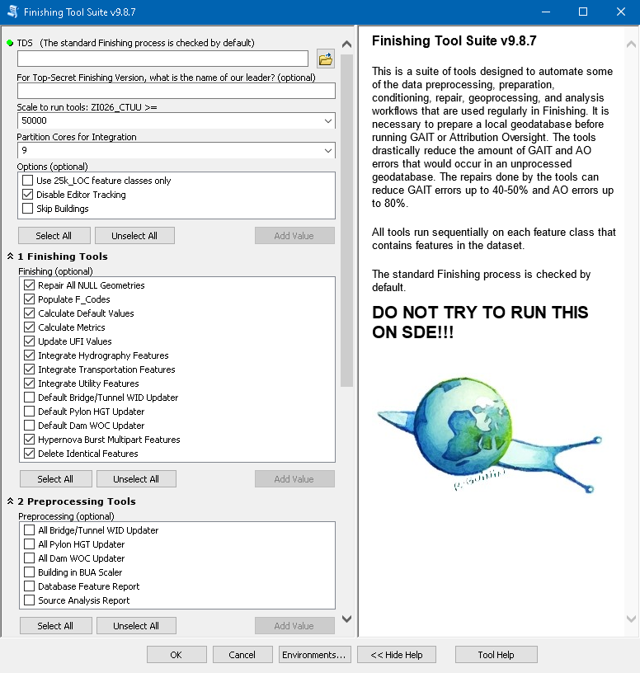

GAIT results **without** the Finishing Tool Suite:

GAIT results **with** the Finishing Tool Suite:

|  |  |  |  |  |  |
| --- | --- | --- | --- | --- | --- |
| **#** | **Condition Error** | **Before** | **After** | **Difference** | **Improvement** |
| 1 | Part Of Multi-part Point | 0 | 0 |  |  |
| 2 | Part Of Multi-part Line | 28 | 0 | -28 | 100% |
| 3 | Part Of Multi-part Area | 269 | 0 | -269 | 100% |
| 4 | Sliver Area | 65 | 65 |  |  |
| 5 | Duplicate Vertices | 0 | 0 |  |  |
| 6 | Complete Duplicates | 1 | 0 | -1 | 100% |
| 7 | Any Two Features With The Same Identifier | 0 | 0 |  |  |
| 8 | Area - Area Undershoot (Gap) | 717 | 717 |  |  |
| 9 | Area - Area Overshoot (Sliver) | 455 | 455 |  |  |
| 10 | Line - Line Undershoot | 27110 | 426 | -26684 | 98% |
| 11 | Line - Line Overshoot | 16603 | 98 | -16505 | 99% |
| 12 | Line - Area Perimeter Undershoot | 74 | 11 | -63 | 85% |
| 13 | Interior Line Vertex - Line Undershoot | 194 | 187 | -7 | 4% |
| 14 | Interior Line Vertex - Line Overshoot | 10 | 6 | -4 | 40% |
| 15 | Line - Area Perimeter Overshoot | 58 | 2 | -56 | 97% |
| 16 | Line Not Cut At Coincidence With Another Line End Node | 2268 | 2213 | -55 | 2% |
| 17 | Line Feature Merge Failure - 1/4 Degree Boundaries Excluded | 46816 | 46815 | -1 | 0% |
| 18 | Area Feature Merge Failure - 1/4 Degree Boundaries Excluded | 5 | 5 |  |  |
| 19 | Feature Connectivity Failure | 282 | 282 |  |  |
| 20 | Point Inside Or On Area Perimeter | 201 | 201 |  |  |
| 21 | Area Not Containing Any Part Of Another Feature | 0 | 0 |  |  |
| 22 | Line Inside Area | 46 | 42 | -4 | 9% |
| 23 | Line End Node Inside Area | 9 | 9 |  |  |
| 24 | Point To Feature Coincidence Failure | 326 | 326 |  |  |
| 25 | Point - Feature Intersection Coincidence Failure | 180 | 180 |  |  |
| 26 | Line Kink | 290 | 10 | -280 | 97% |
| 27 | 'Z' Shaped Line Kink | 2 | 2 |  |  |
| 28 | Line Kink (Single Feature) | 48 | 47 | -1 | 2% |
| 29 | Line Feature Join Kink | 32 | 30 | -2 | 6% |
| 30 | Line Kickback | 3 | 4 | 1 | 33% |
| 31 | Loop (Self-intersecting Area Or Line Feature) | 26 | 26 |  |  |
| 32 | Area Kink Or Kickback | 310 | 310 |  |  |
| 33 | Feature - Feature Intersection Not At Connecting Node | 188 | 0 | -188 | 100% |
| 34 | Line - Line Intersection With Exception | 511 | 511 |  |  |
| 35 | Line Not Covered By Area Or Line | 126 | 127 | 1 | 1% |
| 36 | Two Lines Overlap (Coincident Segments) | 7572 | 7568 | -4 | 0% |
| 37 | Illegal Shared Face | 1370 | 1370 |  |  |
|  | TOTAL | 106195 | 62045 | -44150 | 42% |

## Prerequisites

* ArcMap Desktop 10.5+
* Python 2.7

# Tool Features

## Roadmap

☐ Input TDS Dataset

☐ Top-Secret Finishing Version

☐ Scale to run tools

☐ Partition Cores for Integration

☐ Options

☐ Use 25k_LOC feature classes only

☐ Disable Editor Tracking

☐ Skip Buildings

☐ Finishing Tools

☐ Repair All NULL Geometries

☐ Populate F_Codes

☐ Calculate Default Values

☐ Calculate Metrics

☐ Update UFI Values

☐ Integrate Hydrography Features

☐ Integrate Transportation Features

☐ Integrate Utility Features

☐ Default Bridge/Tunnel WID Updater

☐ Default Pylon HGT Updater

☐ Default Dam WOC Updater

☐ Hypernova Burst Multipart Features

☐ Delete Identical Features

☐ Preprocessing Tools

☐ All Bridge/Tunnel WID Updater

☐ All Pylon HGT Updater

☐ All Dam WOC Updater

☐ Building in BUA Scaler

☐ Database Feature Report

☐ Source Analysis Report

## Usage

**TDS**

|  |  |
| --- | --- |
|  | Add the TDS dataset here. The tools all use this main path. |

**Top-Secret Finishing Version**

|  |  |
| --- | --- |
|  | ¯\_(ツ)_/¯ |

**Scale to run tools**

|  |  |
| --- | --- |
|  | Using the dropdown menu, choose the scale of data that will be processed by the tools. This will be used for querying data.  ZI026_CTUU >= SCALE |

**Partition Cores for Integration**

|  |  |
| --- | --- |
|  | The number of partitions that will be used to subdivide the Transportation, Hydrography, and Utility features during the Integration process. This allows for large scale geoprocessing on limited computer resources. Use more partition cores for larger datasets. |

**Use 25k_LOC feature classes only**

*Option*s

|  |  |
| --- | --- |
|  | With this option checked, tools will only run on the specific 25k_LOC features. |

**Disable Editor Tracking**

*Option*s

|  |  |
| --- | --- |
|  | This disables Editor Tracking on all feature classes in the dataset. If Editor Tracking is not disabled, the current user will be marked as Last Edited on any features the tools edit.  ~Note~ This can be skipped for interim runs, but it needs to be checked for final finishing. |

**Skip Buildings**

*Option*s

|  |  |
| --- | --- |
|  | This will automatically skip the StructureSrf and StructurePnt feature classes for all tools. This option exists because the databases we work on can have upwards of 10-20 million Building features. Our computers cannot handle this. |

**Repair All NULL Geometries**

*Finishing*

|  |  |
| --- | --- |
|  | Runs Repair Geometry and deletes features with NULL geometries. |

**Populate F_Codes**

*Finishing*

|  |  |
| --- | --- |
|  | Identifies features with mismatched F_Code/FCSubtype pairs and updates the F_Codes to match the FCSubtypes.  Original code by John Jackson. Refactored by Nat Cagle. |

**Calculate Default Values**

*Finishing*

|  |  |
| --- | --- |
|  | Identifies text and numeric feature class fields with NULL values. Populates the NULL fields with their schema defined default values. |

**Calculate Metrics**

*Finishing*

|  |  |
| --- | --- |
|  | Updates the spatial calculation of Length (LZN) fields for polyline features and Area (ARA) fields for polygons. |

**Update UFI Values**

*Finishing*

|  |  |
| --- | --- |
|  | Populates Unique Feature Identifier (UFI) fields containing NULL values. Finds and updates feature subtypes with duplicate UFI values within a given feature class. Identifies illegal UFI values that are not 36 alphanumeric characters with a format of {12345678-1234-1234-1234-123456789012}.  _Note_: Duplicate UFI values across multiple feature classes cannot be identified. To avoid this occurrence, analysts must not copy attributes between feature classes.  _Note_: Manually entered, legal UFI values that meet the formatting requirements will not be flagged. This means that the following UFI values are technically valid:  LEONARDO-EATS-FROG-EGGS-DISGUSTINGLY |

**Integrate Hydrography Features \*\***

*Finishing*

|  |  |
| --- | --- |
|  | Selects all Hydrography point, line, and polygon features with CTUU greater than or equal to the user defined scale. Repairs the geometry of the line and polygon features first. Runs the new integration process on each data partition. Repairs the geometry of the line and polygon features after processing. Clears the cached memory of selected features. |

**Integrate Transportation Features \*\***

*Finishing*

|  |  |
| --- | --- |
|  | Selects all Transportation point, line, and polygon features with CTUU greater than or equal to the user defined scale. Repairs the geometry of the line and polygon features first. Runs the new integration process on each data partition. Repairs the geometry of the line and polygon features after processing. Clears the cached memory of selected features. |

**Integrate Utility Features \*\***

*Finishing*

|  |  |
| --- | --- |
|  | Selects all Pylon points, Cable lines, and Utility polygon features with CTUU greater than or equal to the user defined scale. Repairs the geometry of the line and polygon features first. Runs the new integration process on each data partition. Repairs the geometry of the line and polygon features after processing. Clears the cached memory of selected features. |

***\*\* Updated Integration Process***

|  |  |
| --- | --- |
|  | The amount and complexity of features in our databases prevents normal processing due to insufficient computer resources. To combat this, the integration tools partition the features into smaller chunks to allow for processing. The integration process has been updated, and for each data partition, the new integration sequence is performed in descending order of geometric hierarchy.  The new logic works backwards through the geometry hierarchy to minimize feature shift or disjoint. Lines->Surfaces then Points->Lines.  - Incorporated incremental snapping with 0.05m tolerance. - Snap lines to the nearest surface vertex within 0.05m. - Snap remaining lines to the nearest surface edge within 0.05m. - Integrate lines->surfaces with default domain tolerance (ESRI recommended) to create intersection vertices without morphing the features. - Snap points to the nearest line end node within 0.05m as priority over other vertices. - Snap remaining points to the nearest line vertex within 0.05m. - Snap remaining points to the nearest line edge within 0.05m. - Integrate points->lines with default domain tolerance (ESRI recommended) to create intersection vertices without morphing the features. |

**Default Bridge/Tunnel WID Updater**

*Finishing*

|  |  |
| --- | --- |
|  | Identifies Bridge and Tunnel lines with default (-999999) Width ONLY. Calculates the Bridge/Tunnel WID value based on coincident Transportation features and updates mismatched CTUU values. Transportation features include Roads, Railways, Railway Sidetracks, and Cart Tracks. |

**Default Pylon HGT Updater**

*Finishing*

|  |  |
| --- | --- |
|  | Identifies Pylons with default (-999999) Height ONLY. Updates the Pylon HGT value to match the intersecting Cable HGT value and updates mismatched CTUU values. |

**Default Dam WOC Updater**

*Finishing*

|  |  |
| --- | --- |
|  | Identifies Dam polygons with default (-999999) Width of Crest ONLY. Calculates the Dam WOC value based on the Lane Count or Gauge Width of any intersecting Transportation features and updates the Transportation System (TRS). Applies a standard value if the Dam does not intersect any Transportation features. Transportation features include Roads, Cart Tracks, Railways, and Railway Sidetracks.  Original code by John Jackson. Refactored and updated by Nat Cagle. |

**Hypernova Burst Multipart Features**

*Finishing*

|  |  |
| --- | --- |
|  | Identifies all true multipart features within each feature class and explodes all the parts while maintaining original attribution. |

**Delete Identical Features**

*Finishing*

|  |  |
| --- | --- |
|  | Identifies features with identical geometry and PSG attribution and removes any duplicate features. |

**All Bridge/Tunnel WID Updater**

*Preprocessing*

|  |  |
| --- | --- |
|  | Identifies ALL Bridge and Tunnel lines with Width less than or equal to that of their coincident Transportation feature. Calculates a new Bridge/Tunnel WID value based on the coincident Transportation features and updates mismatched CTUU values. Transportation features include Roads, Cart Tracks, Railways, and Railway Sidetracks. |

**All Pylon HGT Updater**

*Preprocessing*

|  |  |
| --- | --- |
|  | Identifies ALL Pylons with Height less than or equal to that of their intersecting Cable. Updates the Pylon HGT value to match the intersecting Cable HGT value and updates mismatched CTUU values. |

**All Dam WOC Updater**

*Preprocessing*

|  |  |
| --- | --- |
|  | Identifies ALL Dam polygons with Width of Crest less than or equal to that of any intersecting Transportation features. Calculates a new Dam WOC value based on the Lane Count or Gauge Width of any intersecting Transportation features and updates the Transportation System (TRS). Applies a standard value if the Dam does not intersect any Transportation features. Transportation features include Roads, Railways, Railway Sidetracks, and Cart Tracks.  Original code by John Jackson. Refactored and updated by Nat Cagle. |

**Building in BUA Scaler**

*Preprocessing*

|  |  |
| --- | --- |
|  | Identifies and descales Building points and polygons within BUAs that meet ALL THREE of the following criteria:   * Have a Feature Function (FFN) value that is NOT on the current project Important Building FFNs list. * Have a Height (HGT) value less than 46 meters. * Have a Navigation Landmark (LMC) value of False.   Identified and scales up Building points and polygons within BUAs that meet ANY ONE of the following criteria:   * Have a Feature Function (FFN) value that IS on the current project Important Building FFNs list. * Have a Height (HGT) value greater than OR equal to 46 meters. * Have a Navigation Landmark (LMC) value of True. |

**Database Feature Report**

*Preprocessing*

|  |  |
| --- | --- |
|  | Scans the entire provided TDS dataset (not affected by the user defined scale). Creates a text file reporting the breakdown of feature classes and feature counts. Includes the following information:   * Total Points, Curves, and Surfaces * Total Hydrography, Transportation, Utility, Building, and Landcover features * Total features per feature class and a count of each subtype * Empty feature classes   Original code by John Jackson. Refactored by Nat Cagle. |

**Source Analysis Report**

*Preprocessing*

|  |  |
| --- | --- |
|  | Scans the entire provided TDS dataset (not affected by the user defined scale). Creates a text file and CSV file reporting the breakdown of source types for each feature class. Includes the following information for each feature class:   * Version * Source Description (ZI001_SDP) * Source Date (ZI001_SDV) * A count for each unique combination of values.   Original code by John Jackson. Refactored by Nat Cagle. |

# Acknowledgments

* John Jackson
* Logo Source: La Maison Commune de la Décroissance  
  [ladecroissance.xyz](https://ladecroissance.xyz/)  
  Artwork by Robin Guinin Dessin  
  Diagram

  Description automatically generated  
  [facebook.com/LE.ROBINOSCOPE](https://www.facebook.com/LE.ROBINOSCOPE/)  
  [r.guinin@netc.fr](mailto:r.guinin@netc.fr)  
  [instagram.com/art2robin](https://www.instagram.com/art2robin)